Down the River Site Plan

GOAL:

Our goal is to create an attractive, riveting, exciting, eye-catching, and truly compelling website which convinces people that river tubing is just as fun, just as exciting and far less expensive than rafting. Instead of being crammed into a large raft, each person has their own personal tube. And you will not be high above the water; you will be in the water enjoying a refreshing respite from the summer heat. We limit our tubing trips to class I and II rapids for beginners and families but offer some class III excursions for experienced river tubers. Excursions on class I and II rapids do not even require a guide.

Our website will use natural colors, stimulating photos, and creative graphics to make the site easy and enjoyable to navigate, yet filled with pertinent facts. We will ensure that responding to the website by booking a tubing trip or just seeking more information will be easy to accomplish. Our main message is that tubing is more fun, more exciting and far less expensive than rafting. It is an outstanding outdoor experience which provides a casual family outing where the goal is just to have svome serious fun while enjoying the beauty of nature. We also offer a catered picnic at the end of your trip. You may choose your picnic from our delicious menu, and we will bring it and serve it to you as you finish your experience.

Goals:

* **Optimize online viesibility:** Provide an attractive website to attract new customers and maintain brand awareness
* **Feature actual experiences:** Emphasize the enjoyment and beauty of tubing experiences by using photos, videos and testimonials of actual tubers.
* **Establish a solid social image:** Create a social media pages with Facebook, YouTube, Instagram, WhatsApp and TikTok.

**Increase Sales:** Advertise special events and group discounts to motivate additional sales.

Target Audience

* **Demographics:** Families seeking unique outdoor experiences, river rafting enthusiasts, school classes looking for unique educational opportunities, corporations looking for team-building experiences
* **Psychographics:** Nature lovers, groups seeking unity, mild adventurers

Scenarios:

* Information on specific trips including difficulty and routes
* Required safety equipment
* Testimonials of previous river tubers
* High quality photos and videos of actual excursions
* Descriptions of family/beginner trips
* Descriptions of advanced trips with age and experience requirements
* Options for scheduling group events
* Recommendations for other nearby activities, lodging, meals, etc.
* Options for customizing the trip (i.e. private guides, overnight trips, meal options, etc.)

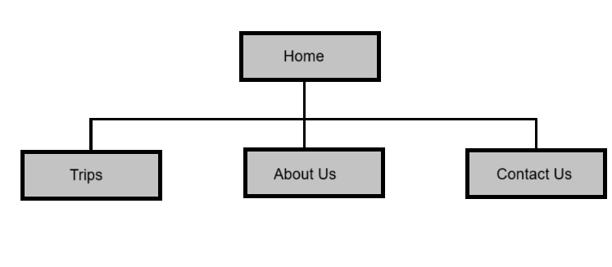Site Map

Branding

Logo

Color Schema

Color Palette URL:

https://coolors.co/d07d31-f6b81a-91a03a-717933-1aa595-7bccc5-af916e-474647

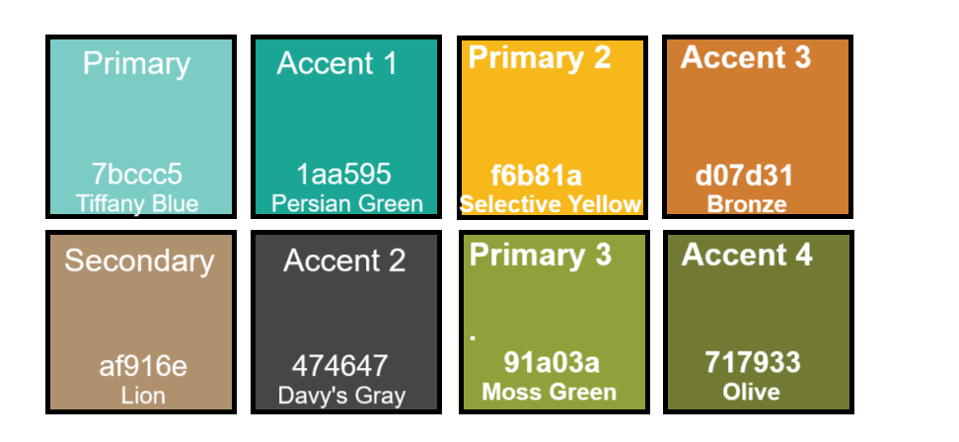

Typography

Headings: Merriweather

Body: Roboto font family